Challenge Template – User Guide

1. Unzip the template
2. Installing the archetype
   * WINDOWS:
     1. Run the ‘install archetype.bat’ found in ‘archetype’
   * OTHER OS :
     1. Open the command prompt in the ‘archetype’ folder
     2. Run the command: cd target/generated-sources/archetype
     3. Run the command: mvn install

Run the command: mvn install:install-file -Dfile=src/main/resources/archetype-resources/src/main/resources/MoCFramework-1.1-Deliverable.jar -DgroupId=MoC -DartifactId=MoCFramework -Dversion=1.1-Deliverable -Dpackaging=jar

1. Open netbeans and create a new project: maven -> project from archetype

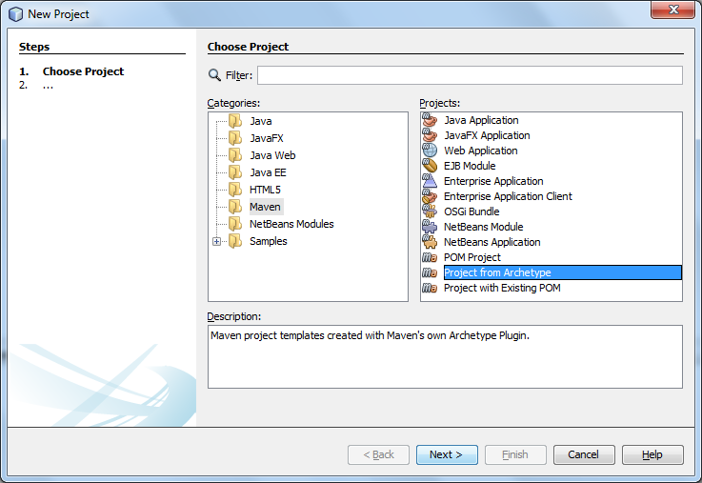

1. Select the MoC-ChallengeTemplate and click next

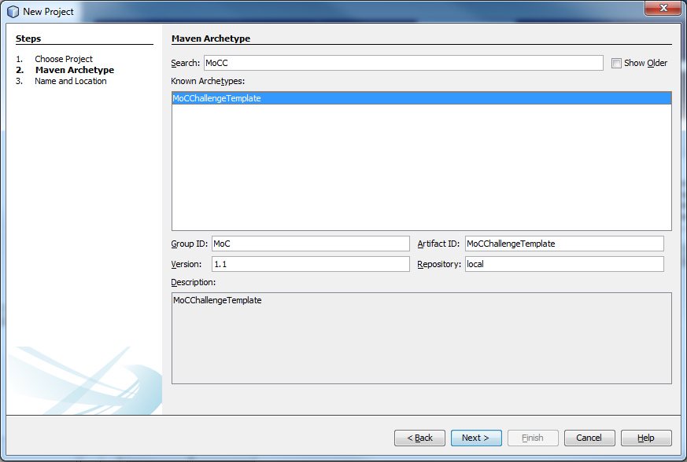

1. After the project is created, use the template to create and configure the challenge

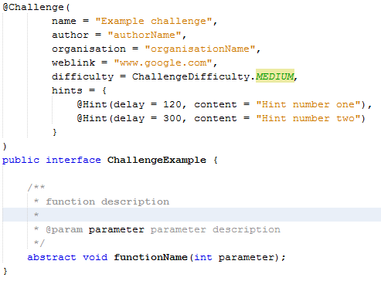

Rename the ChallengeExample interface, configure the information in the @Challenge annotation, and create the abstract functions needed for the challenge.

An array of hints can be added to the Challenge by using the @Hint annotation. A hint consists of a string with the content of the hint, and the delay in seconds which represents the time when the hint will be released after the round has started.

To create a java file that can be edited by the participants, put the annotation @Editable above the class. All java classes without this annotation can’t be edited by the participants.

There are three example tests in the challenge template: a UserTest, a SystemTest and an AmbivalentTest. A user test is a test that can be manually run by the participants while making the challenge. System tests can’t be run manually and will automatically be executed when turning in the challenge. To change the type of a test, change the “groups” property in the @Test annotation.

There are also two .html files. *DescriptionParticipants.html* contains the challenge description as read by the participants. *DescriptionSpectators.html* contains the challenge description as read by the public.

1. After you’re done, make sure to build the project: run -> build
   * Note: you will have to build without running the tests, as the code should not be implemented and the tests should fail. To do this, add custom goals/configurations or build through the command line: ‘mvn -Dmaven.test.skip=true install’
2. A zip file of the challenge can be found in the target map of the project